Credit Risk Analytics Dashboard
PostgreSQL · SQL · Power BI · DAX

Project Overview
This project demonstrates an end-to-end credit risk analytics workflow, starting from relational database design in PostgreSQL to an interactive Power BI dashboard used for portfolio monitoring, delinquency tracking, early warning signals, and collections effectiveness.
The objective was to simulate how analytics teams in banks, NBFCs, and fintech companies track loan performance and identify early risk.

Business Objectives
- Monitor overall loan portfolio health
- Track delinquency (DPD) and risk buckets
- Identify early warning signals (repeat late payments)
- Analyse roll-rate trends over time
- Measure collections and ops effectiveness
- Enable decision-making through dashboards

Data Model & Architecture
Database: PostgreSQL
A normalized relational schema was designed with the following core entities:
- Customer – borrower profile and segmentation
- Loan – credit exposure and loan attributes
- Payment – repayment behavior and delinquency tracking
- Ops Actions – collection actions (SMS, calls, escalation)

To support analytics, SQL views were created as a semantic layer, ensuring:
- Clean data exposure
- Reusability
- Separation of logic (SQL for transformations, DAX for aggregation)

SQL Views Created
The following views power the dashboard:
- vw_loan_risk_summary – loan-level risk and DPD buckets
- vw_monthly_roll_rate – monthly delinquency migration
- vw_early_warning_flags – repeat late payment indicators
- vw_ops_effectiveness – post-action collections analysis
- vw_customer_risk_profile – customer-level risk segmentation
These views were the only objects exposed to Power BI, following best practices.

Power BI Dashboard Design
Page 1: Portfolio Overview
- Total Loans
- Total Exposure
- Delinquency Rate (%)
- Exposure at Risk (%)
- Loan distribution by risk bucket
- Exposure by risk segment

Page 2: Delinquency Trends & Roll Rates
- Monthly DPD migration
- Roll-rate trends across risk buckets
- High-risk loan percentage

Page 3: Early Warning System (EWS)
- Repeat Late Loans
- Repeat Late Rate (%)
- Conditional formatting to flag high-risk loans
- Tabular view for operational follow-up

Page 4: Collections & Ops Effectiveness
- Post-action collections
- Average collection per action
- Performance comparison of automated vs manual actions

DAX Measures (Highlights)
- Key KPIs were built using DAX, including:
- Delinquency Rate
- Exposure at Risk
- High-Risk Loan Percentage
- Repeat Late Rate
- Ops Effectiveness Metrics
- Filter-context issues were handled explicitly to ensure accurate KPIs across pages.

Tools & Technologies
- PostgreSQL – database & SQL views
- pgAdmin – database management
- Power BI Desktop – dashboard & visualization
- DAX – KPI calculations
- SQL – transformations, joins, risk logic

Key Learnings
- Designing analytics-ready SQL schemas
- Using SQL views as a semantic layer
- Handling Power BI filter context issues
- Building real-world credit risk KPIs
- Creating dashboards aligned with business decision-making

Possible Enhancements
- Risk score / PD banding
- Cohort analysis by origination month
- Customer-level drill-through
- Automated refresh with Power BI Service
- Larger synthetic dataset for realism

Screenshots
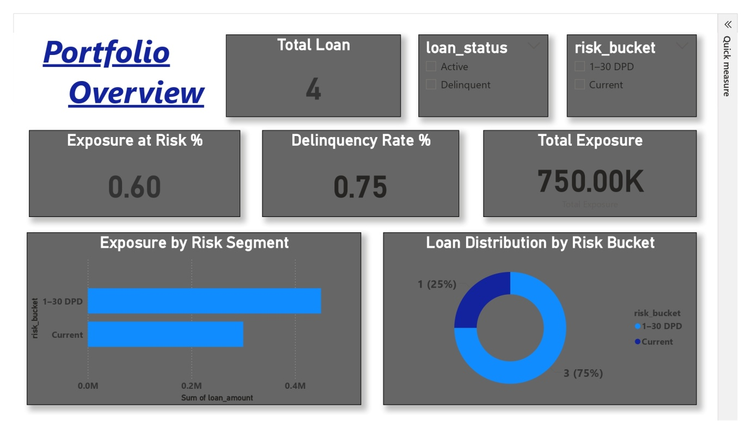
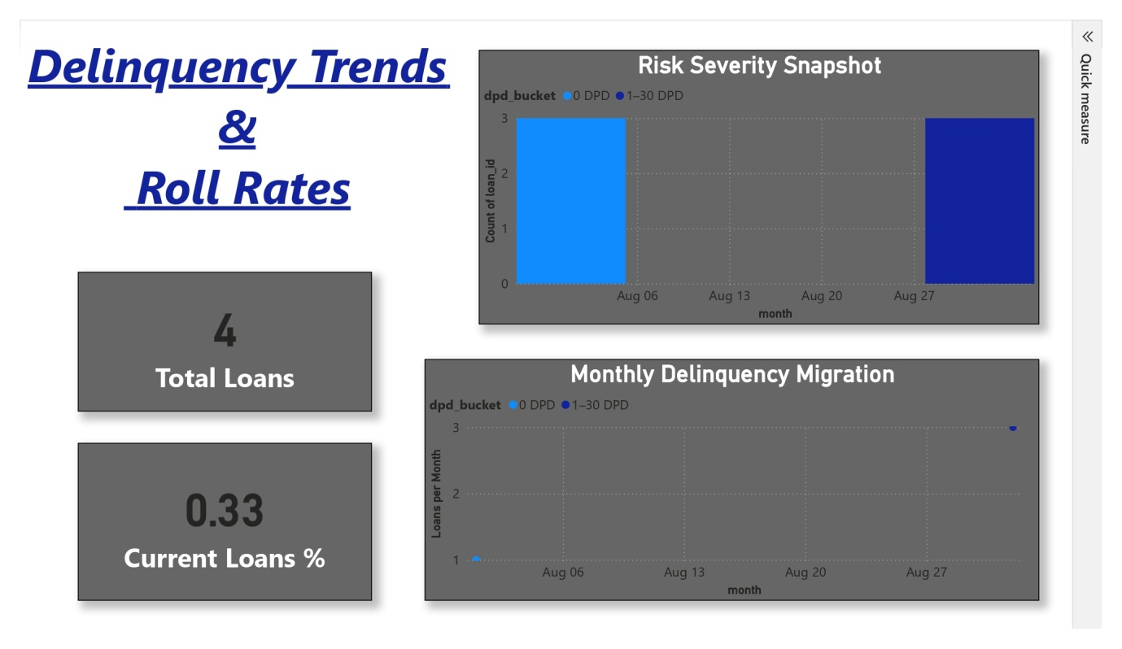
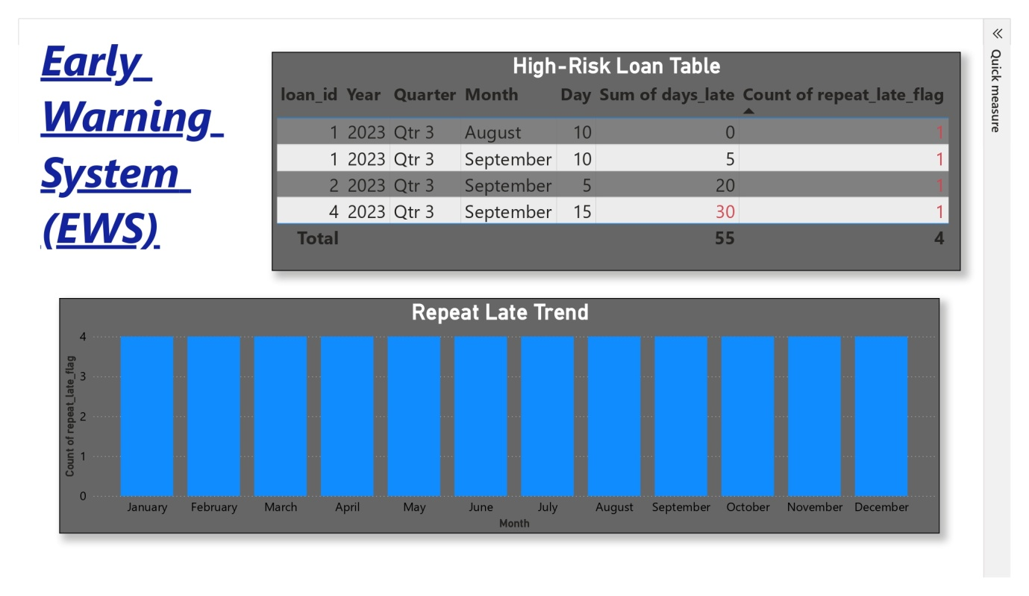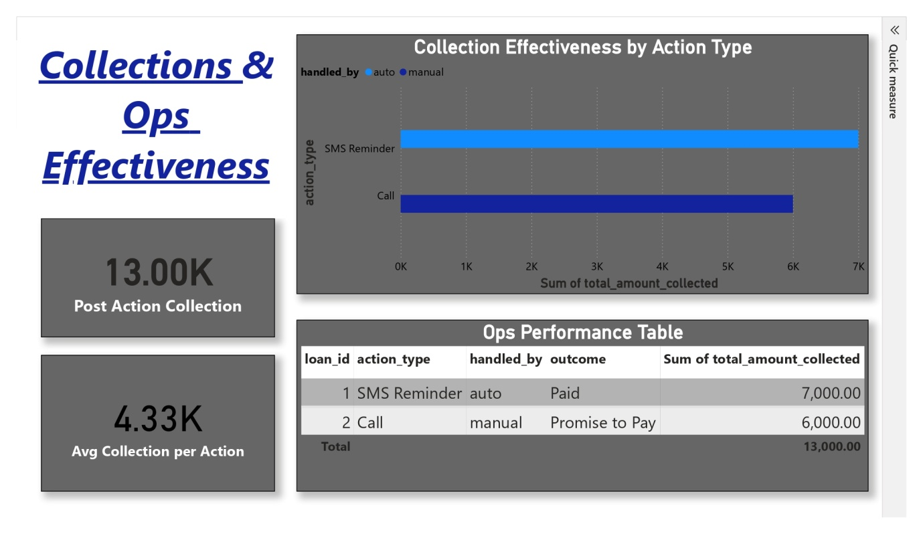

Conclusion
This project demonstrates my ability to design analytics solutions end to end—starting from data modeling and SQL transformation to KPI definition and dashboard storytelling. It reflects real-world credit risk monitoring practices and shows how data can be translated into actionable insights for business and risk teams.

